How to Execute Test Cases in Jira Xray
Oct 1, 2026 · @chakib
First create a Test Execution and add your tests to it (Part 1). Then open each test, work through its steps, and mark it PASS or FAIL (Part 2). A failed test needs evidence and a linked defect.

Part 1: Create a Test Execution
A Test Execution is the Jira issue that holds the tests for one test cycle, release or sprint. Create it before anyone starts testing.

Option A: Create from the Jira Create button
- In the top Jira menu, click + Create.
- In the Project field, select your project.
- In the Issue Type field, select Test Execution.
- In Summary, type a clear name, for example "Release 2.4 – Regression – Oct 2026".
- Fill in the optional fields your team uses: Description, Fix Version, Assignee, Test Environments, Test Plan, and Begin/End Date.
- Click Create.
- Click the new issue key in the confirmation message (bottom left) to open the Test Execution.

Option B: Create from a Test Plan
Use this when your tests are already organized in a Test Plan.
- Open the Test Plan issue.
- In the Tests section, click Create Test Execution.
- Choose which tests to include (all tests, or only the ones you selected).
- Type the Summary and fill in any other fields.
- Click Create. The new Test Execution opens with the tests already added and linked to the plan.

Add tests to the Test Execution
Skip this if you used Option B.
- In the Test Execution, scroll to the Tests section.
- Click Add Tests (in Server/Data Center: Add → Tests).
- Search for tests by key or summary, or switch to Test Sets or JQL to add a whole group at once.
- Check the tests you want and click Add.
- The tests appear in the list with status TODO.

Assign the tests to testers
- Check the boxes next to the tests you want to assign.
- Click … at the top of the list, then Assign.
- Select the tester and click Assign.
- To assign a single test, click … on that row → Assign → select the tester.
The Test Execution is now ready to run.

Part 2: Run the Test Execution (where to click)
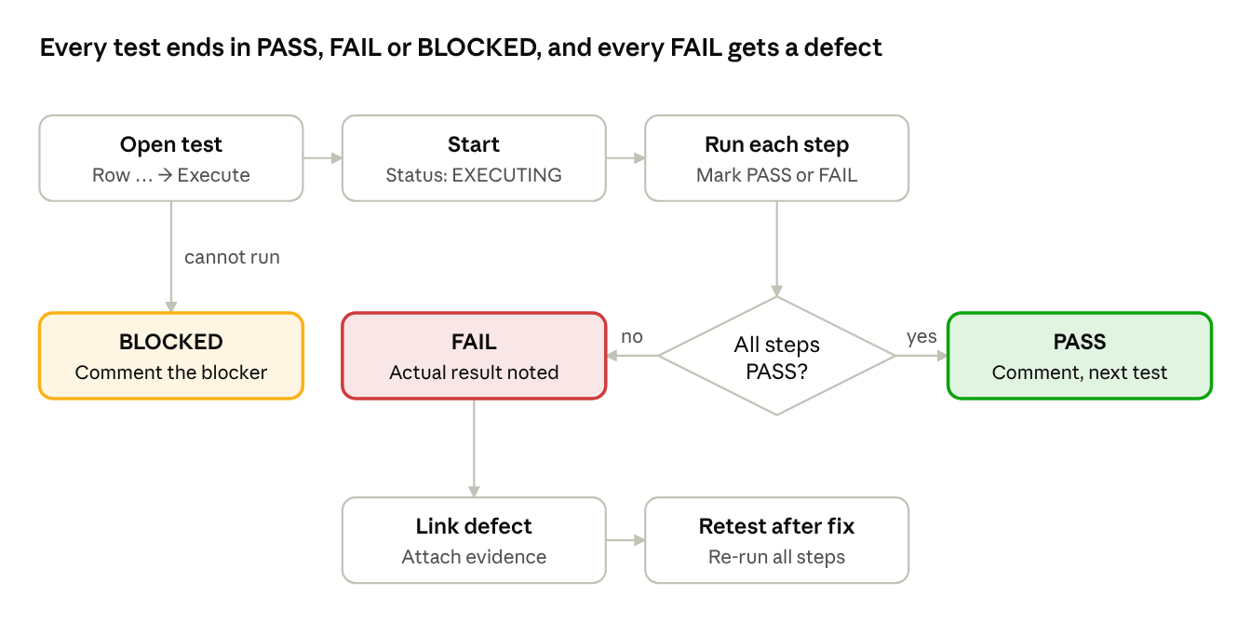
test execution flow · 3 outcomes

A. Open your Test Execution
- In the top Jira menu, click Projects and select your project.
- In the search bar at the top, type the Test Execution key (for example, ABC-123) and press Enter. The Test Execution issue opens.
- Scroll down to the Tests section of the issue.
- At the top of the Tests section, click Filter(s).
- Under Assignee, select your name. Under Execution Status, select TODO. Click Apply.

B. Open the test
- Find the test you want to run in the list.
- At the right end of that row, click … (three dots), then click Execute. In Server/Data Center you can also click the ▶ Execute icon on the row.
- The Test Run screen opens. The top of the screen shows the test key, the summary and the overall Status.

C. Start the test
- Click Start at the top right of the Test Run screen. (Xray Cloud has no Start button; the run starts when you update the first step.)
- Check that the overall Status at the top now shows EXECUTING.
- Read the Preconditions section before you begin.

D. Run each step
- Scroll down to the Test Steps section. Each step shows the Action, Data and Expected Result.
- Perform the action in the application you are testing.
- On the right side of the step, click the step's Status dropdown and select PASS or FAIL.
- If the step failed:
  - Click in the step's Actual Result field and type what happened.
  - In the step's Evidence area, click + (or drag and drop) to attach a screenshot.
  - In the step's Defects area, click +, then Create Defect. Fill in the Summary and Description and click Create.
  - To link an existing bug instead, click +, then Add Defects, search for the bug key and click Add.
- Repeat steps 13 to 15 for every step.

E. Finish the test
- Scroll back to the top and check the overall Status: PASS if all steps passed, FAIL if any step failed.
- Scroll to the Comment field and type the environment and build you tested (for example, "QA environment, build 2.4.1, Chrome").
- Click Next at the top right to open the next test, or click Return to Test Execution at the top left.
If you cannot run the test: at the top of the Test Run screen, click the overall Status, select BLOCKED, and type the reason in the Comment field.
To retest after a fix: return to the Test Execution, click … → Execute on the same test, click Reset at the top, confirm, and repeat sections C to E.
Button names and positions vary slightly between Xray versions. If a label differs on your screen, look for the matching option in the same area.

Status meanings
Status | Meaning
TODO | Not run yet
EXECUTING | Test in progress
PASS | All steps met the expected results
FAIL | At least one step failed; defect required
BLOCKED | Cannot be run because of a blocker
ABORTED | Stopped on purpose
Labels differ slightly between Xray Cloud and Server/Data Center. In Cloud there is no Start button; updating the first step starts the run.

